- The first batch of business surveys for Q2 provided further evidence that the UK economy is leaving the stagnation of the past two years behind. Though it's early days, our forecast that GDP will grow by 0.3% q/q in Q2, after a 0.4% rise in Q1, is on track.
- Comments from members of the Monetary Policy Committee laid bare the divisions in the committee. Our sentiment data, developed with Penta, suggests labour market conditions are steadily loosening and this is pushing down pay growth. This is consistent with a summer rate cut, but the range of views on the MPC suggests a close call between June and August.
After two years of stagnation, the economy finally showed signs of recovery in Q1. And this week's first batch of business surveys for April provided cause for optimism that the recovery has continued into the second quarter.
In particular, the flash S&P Global survey reported a surge in the composite PMI to an 11-month high of 54.0, following a strong pickup in services activity. Over the past couple of years, the composite PMI has had a reasonable record as a leading indicator of official output for the sectors it covers. But the link to GDP has often been weaker because of volatility in the retail and public sectors, neither of which are covered by the S&P Global surveys (Chart 1).
Retail sales rebound strongly in Q1, after December's blip. On the face of it, this week's CBI survey raised renewed concerns in April, with the sales balance slumping to -44 from +2 in March. But the CBI themselves advised to take the results "with a pinch of salt", blaming distortions caused by the early Easter for the poor result. This explanation appears plausible, and we're not particularly concerned about the read across to official retail data. Indeed, March's Office for National Statistics data incorporated a large negative calendar adjustment to try to remove the impact of the early-Easter. So given there should be a compensating boost to the official series in April, it seems unlikely that we will see as weak an outturn as the CBI survey implies.
Chart 1: April's S&P Global survey suggested the recovery continues to gain momentum
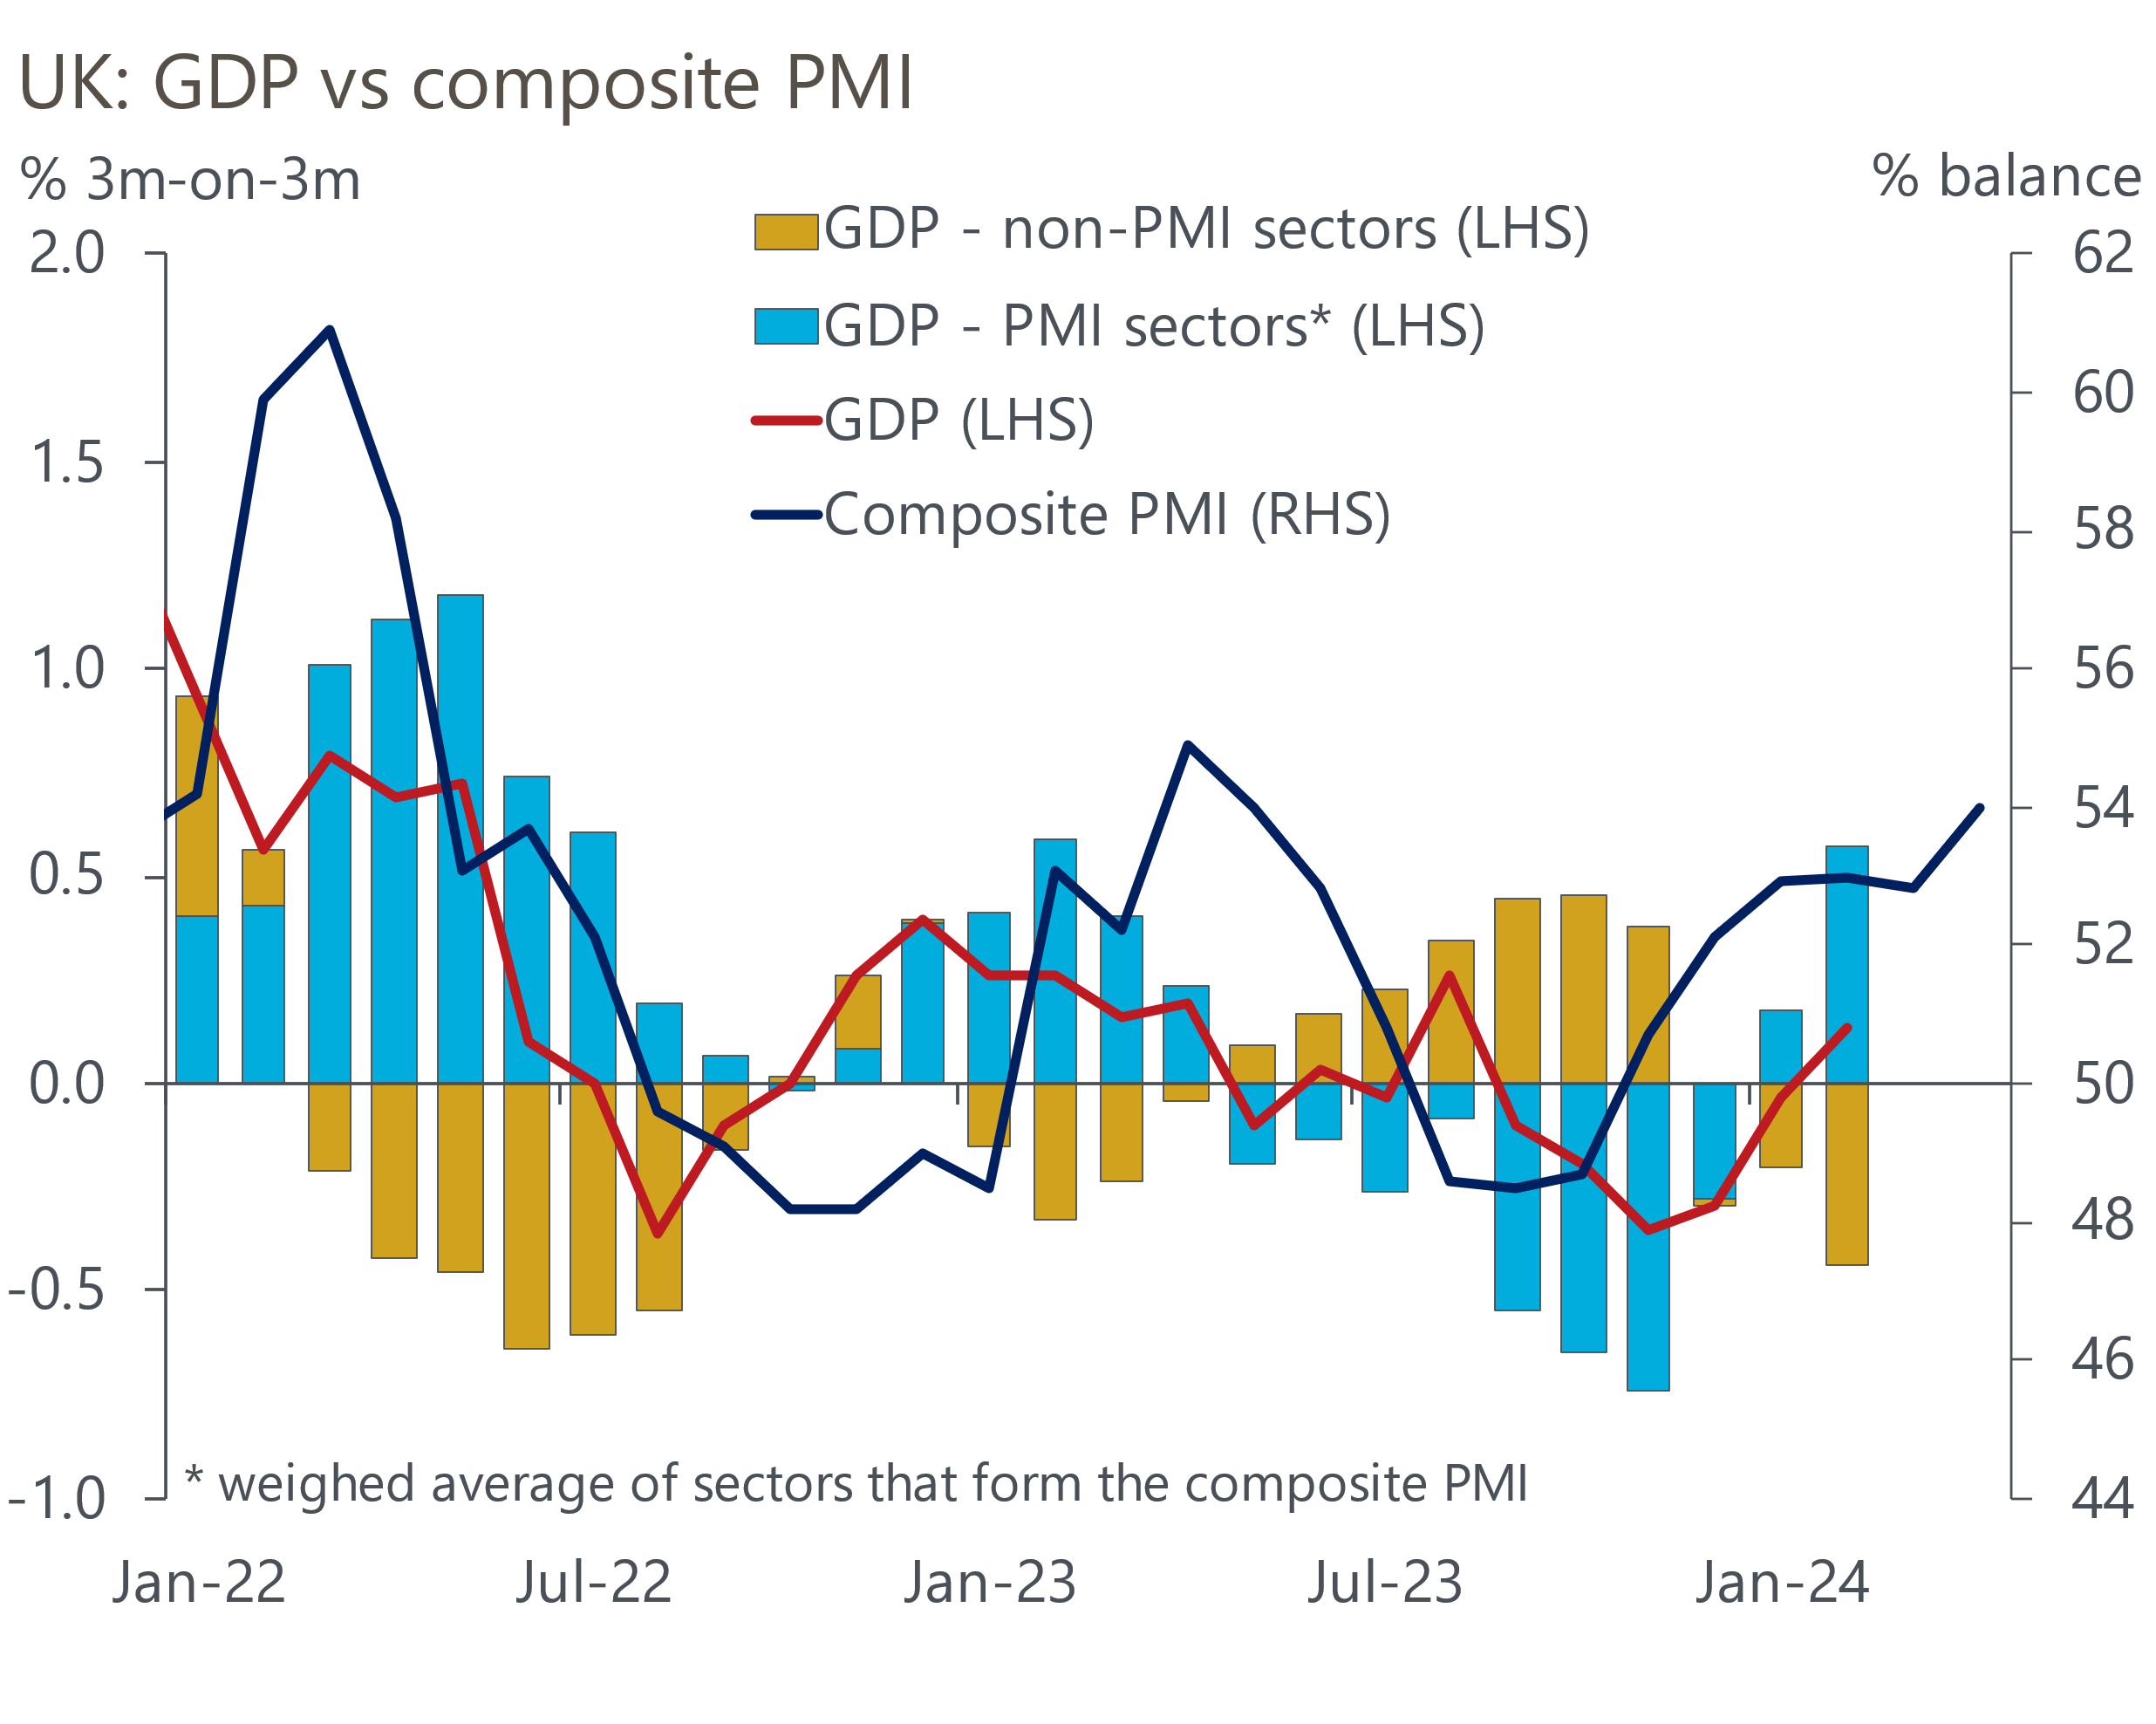
Sources: Oxford Economics, ONS, S&P Global

The current state of the manufacturing sector is even less clear. Official data has been surprisingly strong, with output in February up 2.7% on a year earlier. By contrast, the S&P Global survey has reported a long period of weakness. March's increase in output was the first in 13 months, and the upturn proved short-lived, with output falling again in April. The CBI survey has generally been closer to its S&P Global counterpart, but with smaller falls in production. The CBI's April survey found that output had stabilised over the previous three months, and the forward-looking balances were markedly more upbeat.
On balance, Q2 appears to have started on a relatively strong footing. We doubt that q/q GDP growth will be quite as robust as Q1, which was boosted by the rebound from December's short-lived retail slump. Still, the drag from industrial action is likely to be smaller, given the lower number of working days lost in April and the lack of announcements on future nationwide action by National Health Service staff. It's early days, but our forecast of 0.3% q/q GDP growth in Q2, after a 0.4% rise in the first quarter, is in decent shape.
Turning to the policy outlook, a flurry of comments from Monetary Policy Committee members served to demonstrate the extent to which the Committee is divided. Last Friday's speech by Bank of England Deputy Governor Dave Ramsden was surprisingly dovish, with Ramsden arguing that the balance of risks to domestic inflation are now "tilted to the downside" relative to the BoE's current forecast. But the internal bloc appears to be less united than before. This week BoE Chief Economist Huw Pill said the monetary policy outlook "has not changed substantially" since his March speech, when he had argued that rate cuts were "some way off". Jonathan Haskel, who only stopped voting for rate hikes in March, also argued that rate cuts should be "a long way off", warning that the "very tight" labour market is loosening only slowly.
We think Haskel's verdict might prove too pessimistic. Our sentiment data, developed with Penta, suggests that labour market conditions are steadily loosening, with firms finding it easier to recruit. This has led to a sharp slowdown in our sentiment-data-based pay indicator. If official data mirrors our sentiment indicator, it should keep the MPC on track to cut interest rates in the summer. But the range of views revealed by recent speeches suggests whether a first cut will come in June or August is a close call.
Last weekend's newspapers also hinted at moves on the fiscal front, suggesting the Chancellor would like to implement another cut to employee national insurance contributions before the general election. But we think that scenario is relatively unlikely. The Budget left a tiny margin for error against the fiscal rules of just £8.9bn (0.3% of GDP). Since then, markets have turned more hawkish on the outlook for interest rates (Chart 2). Based on current market pricing, we calculate that more than half of that already-small leeway has been lost to higher debt servicing costs. Theoretically, the Chancellor could create room by gaming the rules and assuming even greater spending restraint. But the current plans already look virtually impossible to deliver, and the government exacerbated that problem this week by doubling down on its existing pledge to increase defence spending. So another tax-cutting fiscal event before the election looks unlikely.
Chart 2: Higher debt servicing costs will limit the government's room for fiscal manoeuvre
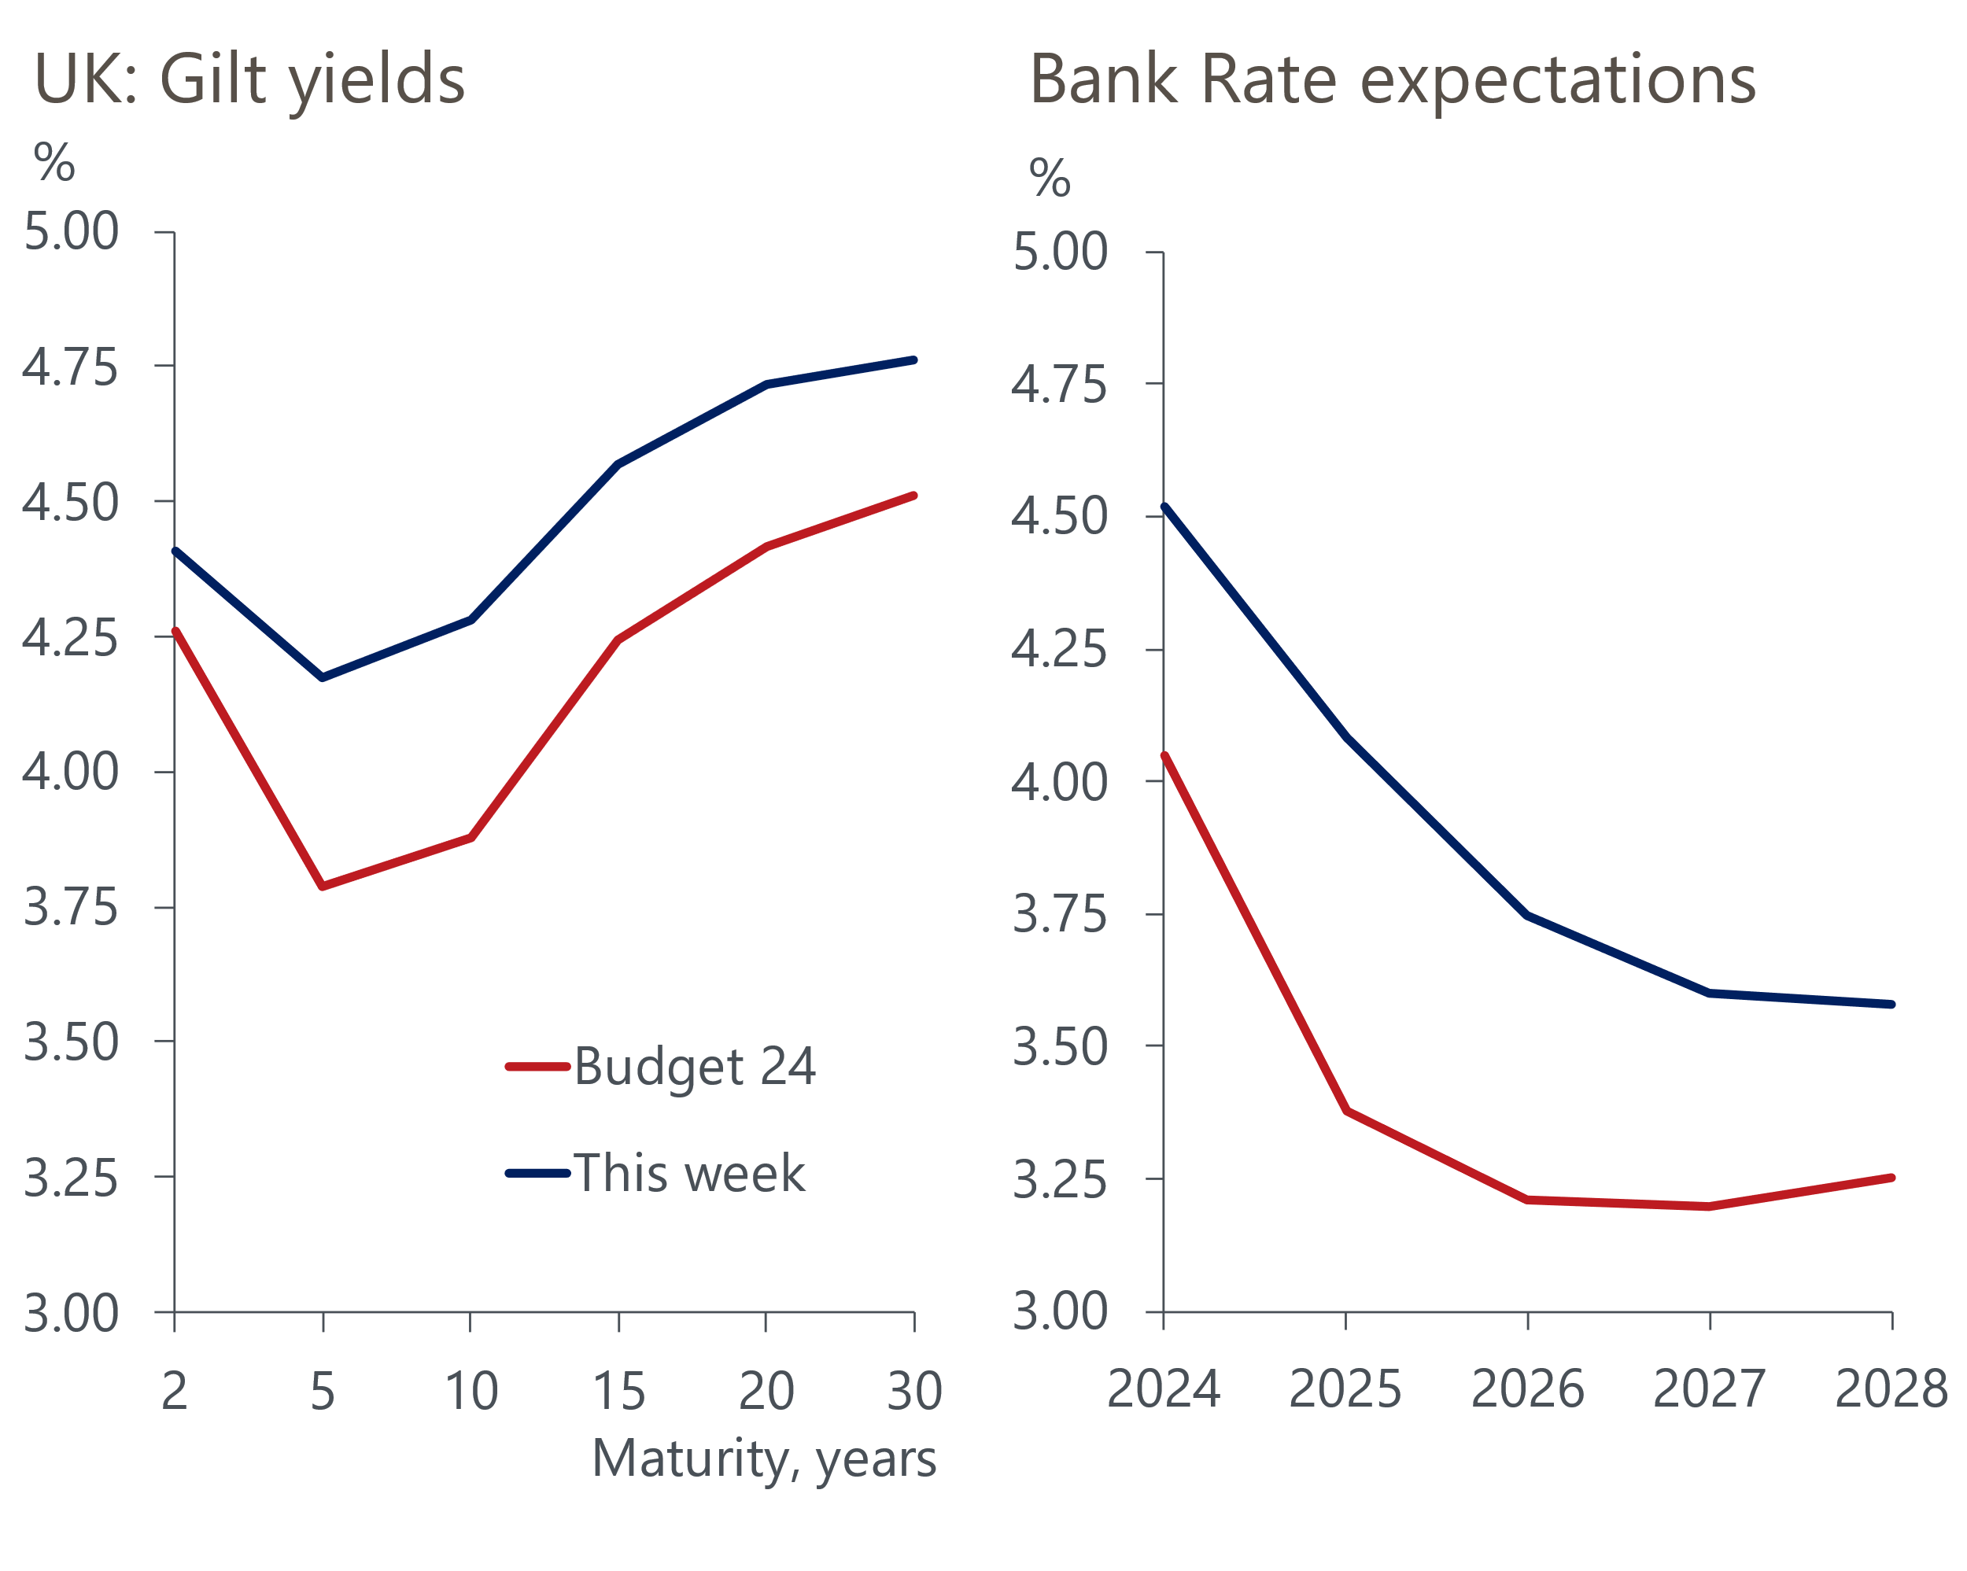
Source: Haver Analytics

The week ahead
Mortgage demand has been strengthening in recent months in response to the sharp drop in mortgage rates since the middle of last year. Though we expect that recovery to have continued into March, we think the increase in mortgage approvals will be much smaller than in recent months due to the uptick in quoted mortgage rates in February and March. We forecast mortgage approvals of 60,800 in March. The recovery in approvals is also feeding through to net lending, albeit with a lag. February's outturn was boosted by a slump in repayments, which may have reversed in March. But we still expect net secured lending to edge up to £1.7bn.
Conversely, higher repayments weighed on net unsecured lending in February. Though gross lending is no longer receiving as much support from high inflation, we think a normalisation in repayments will be enough to raise net unsecured lending to £1.6bn in March.
April's flash PMIs reported further strength in the services sector but renewed weakness in manufacturing. With no clear pattern to revisions, we expect the final results to come in close to the flash results, with the manufacturing PMI at 48.7, services PMI at 54.9 and composite PMI at 54.0.
Table 1: Week ahead calendar
Date | Events | Period | Measure | Unit | Previous | Forecast
Apr 30 | Mortgage approvals | Mar | Level | 000s | 60.4 | 60.8
Apr 30 | Mortgage lending | Mar | Net lending | £bn | 1.5 | 1.7
Apr 30 | Consumer credit | Mar | Net lending | £bn | 1.4 | 1.6
May 1 | S&P Global/CIPS manufacturing | Apr | PMI | % bal | 48.7 | 48.7
May 2 | Nationwide house prices | Apr | m/m | % | -0.2 | 0.0
May 2 | Nationwide house prices | Apr | y/y | % | 1.6 | 1.0
May 3 | S&P Global/CIPS services | Apr | PMI | % bal | 54.9 | 54.9
May 3 | S&P Global/CIPS composite | Apr | PMI | % bal | 54.0 | 54.0
Source: Oxford Economics

Key forecasts
Table 2: UK forecast overview
(Annual percentage changes unless specified)
 | 2022 | 2023 | 2024 | 2025 | 2026 | 2027
GDP | 4.3 | 0.1 | 0.6 | 2.0 | 2.0 | 1.6
Private consumption | 4.8 | 0.2 | 1.0 | 2.6 | 2.2 | 1.6
Fixed investment | 8.0 | 2.2 | -2.8 | 1.1 | 2.8 | 2.1
Government consumption | 2.3 | 0.5 | 4.1 | 2.2 | 1.5 | 1.5
Exports of goods and services | 9.0 | -0.5 | -0.8 | 2.8 | 2.4 | 1.7
Imports of goods and services | 14.6 | -1.5 | 1.5 | 3.9 | 2.9 | 1.9
Industrial Production | -3.5 | -0.3 | 0.1 | 0.9 | 1.5 | 1.2
Consumer prices | 9.1 | 7.3 | 2.3 | 2.2 | 2.3 | 2.2
Unemployment rate (%) | 3.9 | 4.0 | 4.2 | 4.0 | 3.8 | 3.8
Current a/c balance (% of GDP) | -3.1 | -3.3 | -2.9 | -3.0 | -3.0 | -3.0
Government balance (% of GDP) | 4.4 | 5.0 | 3.5 | 3.1 | 2.3 | 1.5
Cen. bank policy rate (%, EOP) | 3.50 | 5.25 | 4.50 | 3.50 | 2.50 | 2.00
10yr govt. bond yield (%, EOP) | 3.67 | 3.54 | 3.87 | 3.51 | 3.08 | 2.85
Exchange rate (US$ per £, EOP) | 1.20 | 1.27 | 1.26 | 1.27 | 1.30 | 1.32
Exchange rate (euro per £, EOP) | 1.13 | 1.15 | 1.17 | 1.17 | 1.17 | 1.16
Source: Oxford Economics
Table 3: Quarterly forecasts for the UK
 | 2024 |  |  |  | 2025
 | Q1 | Q2 | Q3 | Q4 | Q1 | Q2 | Q3 | Q4
GDP (% year) | 0.0 | 0.2 | 0.7 | 1.6 | 1.7 | 2.0 | 2.1 | 2.2
CPI inflation (% year) | 3.5 | 1.9 | 1.8 | 2.1 | 2.0 | 2.0 | 2.3 | 2.3
Bank Rate (%, EOP) | 5.25 | 5.00 | 4.75 | 4.50 | 4.25 | 4.00 | 3.75 | 3.50
10yr gilt yield (%, EOP) | 3.95 | 4.10 | 3.97 | 3.87 | 3.79 | 3.71 | 3.62 | 3.51
US$ per £ (EOP) | 1.26 | 1.25 | 1.25 | 1.26 | 1.26 | 1.26 | 1.27 | 1.27
Euro per £ (EOP) | 1.17 | 1.17 | 1.17 | 1.17 | 1.17 | 1.17 | 1.17 | 1.17
Source: Oxford Economics

Latest Country Economic Forecast:
April 22, 2024

Recent publications

Data Insights
Flash PMIs suggest economic recovery is gaining momentum
Borrowing overshot OBR's forecast in 2023-2024
Flat sales in March caps off a strong Q1 for retailers
Inflation surprised on the upside in March
Pay growth remains resilient, reducing chances of a May cut

Research Briefings
Nowcast shows wage growth slowing sharply
What the Bernanke review says about the state of forecasting
Inflation to dip below 2% in H2 2024, but rise slightly in 2025
The MPC and rates - preparing to descend Table Mountain
MPC remains on track for a June rate cut

Contacts

Oxford Economics' UK team
- Andrew Goodwin - Chief UK Economist - agoodwin@oxfordeconomics.com
- Edward Allenby - UK Economist - eallenby@oxfordeconomics.com

